November 2007

An Ir Amim Position Paper

Winning the Battle, Losing the War:
40 Years of Israeli Rule in East Jerusalem

Executive Summary
A notable recent arrival in Jerusalem has made the following statement on the Israeli-Palestinian conflict:
“The absolute priority is to try to give effect to what is now the consensus across the international community – that the only way of bringing stability and peace to the Middle East is a two-state solution.”

With regard to achieving Mideast peace he added: “I have a view that this is part of something which is far bigger”.

The notable behind these statements is former British Prime Minister Tony Blair, recently appointed to become Middle East envoy working on behalf of the US, Russia, the UN and the EU. Blair has appropriately set offices in Jerusalem – the Holy City at the heart of the Israeli-Palestinian conflict, the place where in the absence of an agreed settlement there will be no Mideast peace.

Blair’s robust statements may seem self-evident, and yet in and around Jerusalem self-evident construction work, developments and future plans are already taking place at an escalating rate, setting the city on a collision course with any attempt for a negotiated compromise in the city. Such developments run contrary to both Israeli and Palestinian mainstream interests, but sadly neither side seems sufficiently committed or able to take the necessary steps to prevent disaster in Jerusalem.

In the first sections of this up-to-date paper Ir Amim outlines how a relatively stable balance of conflicting forces was formed in the Jerusalem area since 1967, allowing for ambiguities that maintained the fragile, albeit fraught, reality in the city for more than three decades (see sections II and III).

This situation dramatically changed since 2002, with the construction by Israel of the separation barrier. At the same time, other processes originating earlier continued developing in and around Jerusalem. We carefully analyze the already evident implications of the (partially completed, partially still under construction) barrier in terms of geography, economy, mobility, security and stability, and point out the ways in which its further building, alongside other factors, can impact Jerusalem and the conflict (sections IV and V). Special emphasis is given to the dangerous development in the most-sensitive part of the city, the Holy Basin (section VI). We conclude this paper with a short summary (section VII), followed by Ir Amim policy recommendations. (section VIII).

This Ir Amim position paper is presented with a sense of urgency attached to our careful study of this unique city - as unilateral actions are already taking place. These actions jeopardize the very possibility for a negotiated peace in Jerusalem – and thus, the very possibility for a Mideast settlement. Time is running out for the city of Jerusalem and for those who still have faith in its name meaning “city of peace”.

I. Introduction
Over the last 40 years, Israeli policy has succeeded in strengthening the Jewish character of Jerusalem by unilaterally redrawing the municipal boundaries and by populating East Jerusalem with Jewish neighborhoods and Israeli institutions. At the same time, through land expropriation and restrictive planning and development policies, Israel has weakened Jerusalem’s Palestinian population.
In recent years, Israel has reinforced these actions by making unprecedented changes to the metropolitan Jerusalem area. From construction of the security barrier to the tacit support of Jewish settlement in Palestinian neighborhoods in and around the Old City, Israel has gone further than ever towards the creation of “Greater Jerusalem,” an entity whose growing Jewish population stands in contrast to the fractured Palestinian community inside it.

At first glance, the resulting increase of Israeli control in and around Jerusalem would seem to further Israeli interests. However, if the success of a two-state solution depends in part on the creation of a viable Palestinian state with East Jerusalem as its capital, Israel is rapidly moving down a road that forecloses this option.

This paper outlines the crucial elements of Israeli policy in East Jerusalem today and traces the factors that damage the city’s relative stability and distance Israel from a bilateral settlement of the conflict.

II. A Fragile Balance
For Israel, an inherent tension exists between the impetus to achieve sovereignty over a Jerusalem that is large, defensible, and Jewish, and the reality that Jerusalem contains a largely separate Palestinian population with its own extensive roots in and connections to the city. This tension has often resulted in policies that allow both Israel and the Palestinian community to straddle a paradox-filled middle ground.
Palestinian residents of Jerusalem hold permanent residency status but are not citizens of the state of Israel. In 1967, after its victory in the Six Day War, Israel expanded the city’s municipal boundary – then only 38 square kilometers (15 square miles) – to include 70 additional square kilometers of West Bank territory, and applied its law, jurisdiction and administration to what became known as East Jerusalem. This area incorporated what had been Jordanian Jerusalem since the 1948 war, an area of some six square kilometers, plus parts of 28 outlying villages, nearly tripling the city’s size. Consequently, while according to international law East Jerusalem is occupied territory, according to Israeli law East Jerusalem is part of Israel and distinct in status from the rest of the West Bank.

In 1967, there were approximately 70,000 Palestinian residents in the city. Israel offered them citizenship; however, the offer was not carte blanche. Rather, it was an invitation to apply for citizenship through regular administrative channels. Acceptance of the offer of citizenship would have meant, among other things, forfeiting the Jordanian passport most residents possessed. For Jerusalem’s Palestinian residents, possessing an Israeli passport would have prohibited their entrance into every country in the Arab world. In keeping with their opposition to Israeli rule, most Palestinian residents of Jerusalem declined to apply for citizenship and were given instead an Israeli identity card that conferred permanent residency status – a status unique among Palestinian residents of the West Bank.

Their Israeli identity card permits ‘Jerusalem residents’ (as Palestinian Jerusalemites came to be known) to travel and work throughout Israel and to receive both Israeli state benefits and Jerusalem municipal services. Residents are also entitled to vote in municipal, but not national, elections. These entitlements, particularly the right to travel and work in Israel, have proven very significant over the years. So, although Palestinian residents have not become citizens and cannot vote in the Israeli Parliamentary system, they receive social and economic benefits from the government system that governs their lives.

To some degree, Palestinian Jerusalemites accepted the benefits and obligations they had been granted: they work in Jerusalem and Israel, pay taxes, and receive social security.

In other ways, the Palestinian community in Jerusalem maintained its autonomy. For example, although Israel at first insisted on the use of the Israeli Arab curriculum in East Jerusalem schools, following prolonged parents’ strikes the community was allowed the continued use of the Jordanian curriculum. Similarly, despite some initial efforts to gain control over the holy sites, Israel immediately relented in the face of vigorous protest, and the Muslim and Christian establishments maintained exclusive control of their respective properties.

Importantly, Palestinian Jerusalemites maintained strong business and family ties with West Bank communities, despite their distinct Jerusalem resident status. Most significantly, Palestinian Jerusalemites adopted an overall strategy of non-cooperation with the Israeli authorities. This found its clearest expression in Palestinian refusal to participate in or to advance candidates for municipal elections.

The willingness of both Israel and the Palestinians to contain certain contradictions enabled both to maintain a fragile balance in the city and to keep a potentially explosive situation in check.

Today, Jerusalem is home to over 700,000 residents, approximately 2/3 of whom are Jewish and 1/3 of whom are Palestinian. For both Israelis and Palestinians, Jerusalem is a primary symbol of nationhood. It is a spiritual and religious center for Muslims, Christians and Jews, the capital of the State of Israel, the center of the West Bank – and the largest city of either entity. For both communities, then, Jerusalem lies at the heart of the Palestinian-Israeli conflict.

Since the fall of 2000 and the onset of the Al-Aqsa intifada, Israel has undertaken a series of unilateral actions in the city that threaten to undermine Israel’s long-term interests. While each of these actions, in and of themselves, may not represent a radical departure from previous policy, their cumulative impact on the ground is unprecedented.

- Gradual Restrictions
While Israeli policy has always been motivated by the desire to increase control over Jerusalem and to maintain a substantial majority of Jews in the city, the restrictions it has imposed to achieve these ends have changed gradually over time in response to evolving realities on the ground. In recent years, for example, security concerns have grown, as has the political pressure to reach an accord regarding Jerusalem’s future. In response, new policies have emerged that impact the city and the region, as will be described in detail below.

In keeping with its goal of maintaining a Jewish majority in the city, for many years Israel encouraged Palestinian residents to live outside Jerusalem’s municipal boundaries. It did so both through restrictive development policies that limited Palestinian growth in the city, and by allowing residents to relocate outside of Jerusalem while initially retaining their Jerusalem residency status. The resulting movement of Palestinians from East Jerusalem, as well as the influx of residents and businesses from other parts of the West Bank, led to substantial development of Jerusalem’s eastern suburbs.

At the same time as Jerusalem’s Palestinian suburbs developed, Israel rigorously managed the “public space” within the Jerusalem municipal boundaries. It regenerated a Jewish connection with parts of the city that had been cut off from Israel during the 19 years of Jordanian rule. It expropriated approximately one third of Palestinian land holdings in East Jerusalem to build large Israeli neighborhoods such as Gilo, French Hill, Ramat Eshkol, Pisgat Ze’ev and Neve Yaakov. In addition, it located important Israeli institutions in East Jerusalem, such as the Israeli National Police Headquarters, the District Court of Jerusalem, and the National Border Police Headquarters. Israel zoned another third of Palestinian land holdings in the city for “preservation,” thereby restricting their development. Problems with its registration status conveniently make it illegal to build on most of the remaining land. In this way, Palestinian development inside Jerusalem is severely limited. The result has been overcrowding inside the city, combined with an exodus of tens of thousands of Palestinian residents to the eastern suburbs where land was cheaper and more plentiful, and, being outside the Jerusalem municipal boundaries, there were no municipal taxes and the same planning restrictions did not apply.

Other Israeli policies also affected the quality of life of Palestinian residents inside the city. In 1967, the difference between existing infrastructure in East and West Jerusalem was enormous. Following the 1967 war, Israel made numerous improvements in the eastern part of the city, especially in areas like the Old City, which directly impacted Jewish residents. However, for Palestinian Jerusalemites this gap was never even remotely closed, and the infrastructure disparities remain huge. Moreover, the city of Jerusalem consistently allocated, on average, less than 10% of the city budget to Palestinian neighborhoods, in which today a third of the city’s population lives.

Palestinian political organizing in Jerusalem was also limited. The Palestinian community was in many ways slow to recover from the 1967 war and to acknowledge the “permanence” of Israeli rule in Jerusalem. This led to a lag in institutional development that was taken advantage of by Israel, who repressed Palestinian civic and political organizing in the city. Eventually, institutions such as the Orient House developed and enjoyed, for a period, a central role in Palestinian political life. For example, with Faisal Husseini at its helm the Orient House took on a central role in the Oslo negotiations and served as the representative of Jerusalem’s Palestinian community. Due in part to this status, in 2001 Israel closed the Orient House, and thereby dealt a powerful blow to Palestinian civic life in Jerusalem. As a result of the limitations imposed upon secular political organizing, the Temple Mount and other sacred sites in the Old City increasingly began to represent some of the few areas of Palestinian control in Jerusalem.

For the first twenty years of Israeli rule, then, the Jerusalem Palestinian metropolitan area grew even while growth within the Israeli-drawn municipal line was restricted. At the end of this period, after the first intifada and the Gulf War, the security situation in Israel began to deteriorate and Israel responded by restricting the entrance of Palestinians from the West Bank into Jerusalem. As terrorist attacks increased significantly in tandem with the Oslo process, Israel also introduced a permit system that institutionalized prohibitions on the entrance of West Bank residents to Jerusalem.

For many in the Palestinian community, these years were characterized on the one hand by the sense of possibility generated by the Oslo Accords, and on the other hand by growing administrative restrictions on the access of West Bank Palestinians to Jerusalem as well as on Palestinians in Jerusalem. As a result, the character of Palestinian Jerusalem began to change. Palestinian Jerusalemites who had moved to the city’s eastern suburbs began to return to Jerusalem, partly in order to protect against the possibility of losing their status, and in order to maintain Israeli social benefits. Crowding increased inside Jerusalem at the same time that institutions and businesses began to feel the loss of their West Bank clientele. Ramallah grew in importance as a political, cultural and economic center. However, it was only after the breakdown of the Oslo peace process and the beginning of the second intifada in late 2000 that Israeli policy began to result in unprecedented changes to the Palestinian Jerusalem metropolitan area.

- The Separation Barrier – a Sea Change
In 2002, a year in which more than 420 Israelis were killed by terrorist attacks, and more than 1,000 Palestinians were killed, the government of Israel decided to construct a barrier, on as well as east of the Green Line, between Israel and parts of the West Bank. More than 150 kilometers (some 100 miles) of the 760-kilometer barrier were slated to wind in and around Jerusalem.

Three aspects of the barrier’s route in the city have particular bearing on the possibility for a future settlement of the conflict. First, the barrier largely follows the Jerusalem municipal line as decided unilaterally by Israel in 1967. This expanded Jerusalem boundary reflected, in 1967, Israel’s desire for militarily defensible borders as well as for more land, while at the same time minimizing the number of Palestinians within those boundaries. The importance of an “undivided” Jerusalem was not then part of the Israeli lexicon. As stated earlier, the new municipal boundary cut through 28 Palestinian villages surrounding Jerusalem, many of which, in those years, were largely agricultural. After 40 years of growth and development, during which time the Palestinian population of Jerusalem more than tripled from approximately 70,000 in 1967 people to some 240,000 today, the area is now densely populated. Placement of the barrier along this line not only fragments and damages the Palestinian metropolitan area of Jerusalem, but it also signals Israel’s intent to maintain control of the entire Jerusalem municipality, east and west.

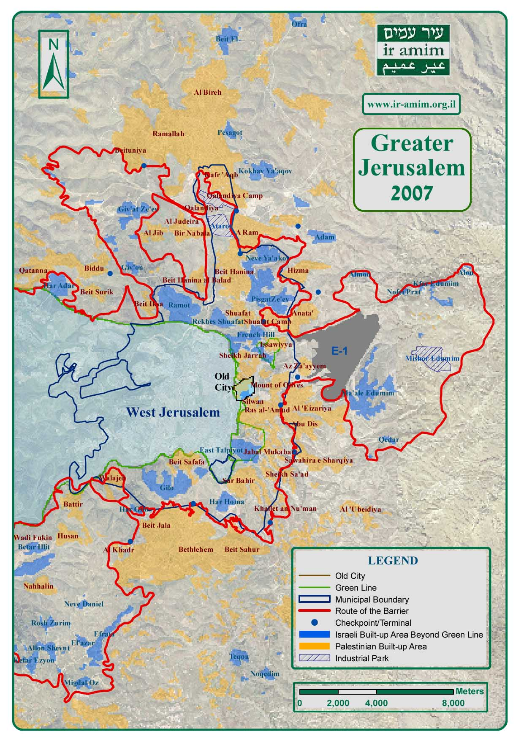

But this principle of placing the barrier along the June 1967 municipal boundary is not without exception. The barrier cuts inside the city line around two Palestinian neighborhoods and de facto removes them from Jerusalem, thereby leaving 55,000 Jerusalem residents, or nearly one quarter of Jerusalem’s Palestinian population, separated from the city. The amount of land occupied by these two areas, the Shuafat refugee camp area and Kafr Aqeb-Semiramis, is small compared to their population densities. By choosing to place them outside of the barrier, Israel substantially – if unofficially – reduces the number of Palestinian residents in the city, while ceding little in the way of territory.

The barrier also deviates from Jerusalem’s municipal line in order to connect the city with the three Israeli settlement blocks of Gush Etzion in the south, Ma’aleh Adumim in the east, and Givat Ze’ev in the north. Rather than merely attaching existing settlements to the city, the barrier encircles large tracts of undeveloped land surrounding them. All told, the barrier will enclose a total of 164 square kilometers (64 square miles) of West Bank territory in the Greater Jerusalem area.

The most strategically important of these areas is E1 (short for ‘East of Jerusalem #1’). This area, while straddling the “bridge” of land between the Jerusalem municipal line and Ma’aleh Adumim, at the same time represents a critical area for the development of the Palestinian metropolitan area of Jerusalem (see map).

By connecting “E1” and similar areas to the city, the barrier strengthens Israeli Jerusalem by de facto adding territory to it for future development and by linking the city with its Israeli hinterland. It achieves these ends by weakening the Palestinian metropolitan area of Jerusalem, fracturing it into enclaves and surrounding it with Israeli-controlled areas, thus further impairing the viability of a future Palestinian state.

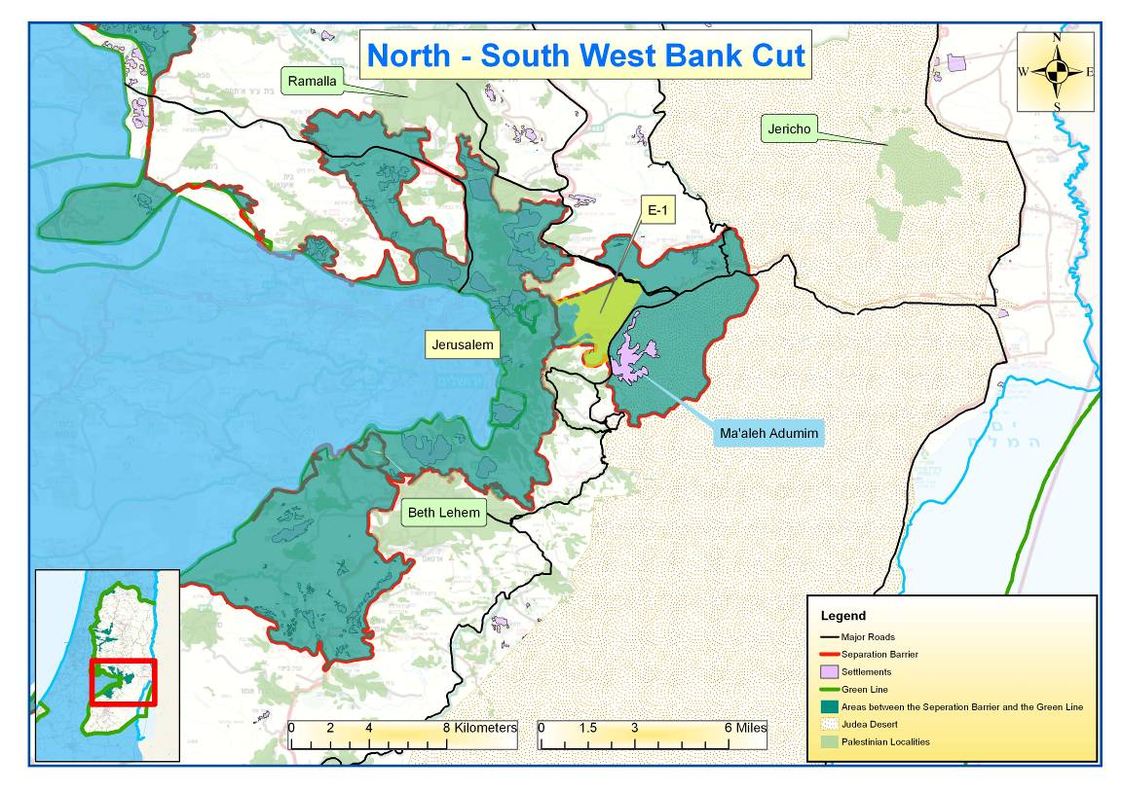

The impact of these changes is tremendous. The barrier’s augmentation of Israeli control of the physical space in and around the city and, as we describe below, its crippling of Palestinian daily life, represent a qualitative departure from previous Israeli policy in East Jerusalem. It reduces the possibility of achieving a bilateral agreement on the future of the city at the same time as it may decrease security for all Jerusalem residents.

V. How the Separation Barrier affects life within Jerusalem
Construction of the barrier has been accompanied by a marked shift in population patterns. In order to preclude the future loss of their residency status and to circumvent the logistical difficulties imposed by the barrier, Palestinian Jerusalemites are returning to live inside the city center by the tens of thousands. While this phenomenon began in the 1990’s, it has swelled with construction of the barrier. Precise numbers are as yet unavailable; however, initial reports indicate that Palestinian families are moving into traditional Palestinian neighborhoods and increasingly also into Jewish neighborhoods of Jerusalem. This is at odds with Israel’s stated security goal in constructing the barrier – to separate Israelis and Palestinians.

The influx of Jerusalem Palestinians back into the city has resulted in significant overcrowding in Palestinian neighborhoods and has created additional pressure on the city’s infrastructure and economy. High demand for property is inflating real estate prices inside the barrier while prices plummet outside its route. The impact is being felt disproportionately by weaker segments of the community who, unable to move, are affected by changing prices that further reduce their already low purchasing power. In addition, the newly vacant properties outside the barrier are attracting residents from the West Bank whose access to Jerusalem is in any case limited by Israeli permit policies.

Likewise, small businesses and public institutions are suffering. The overall impact of the barrier means a reduction in the customer base of many institutions and businesses. At the same time, workers from the West Bank are prevented from reaching their places of employment. East Jerusalem schools and hospitals that rely on West Bank employees have particularly suffered. This in turn contributes to a decline in employment opportunities in East Jerusalem and a potential loss of institutions, commercial and public alike. Although the situation is fluid and data limited, there is a risk that as a result Palestinian Jerusalem’s middle class – comprised of business owners and professionals – is leaving the city. This phenomenon is hardly new, but it is gathering momentum. While the exodus of some Palestinian Jerusalemites may be more than matched, at least numerically, by the return of so many others, the strength of Jerusalem’s economy is disproportionately affected when business owners leave.

In addition, increased housing prices and waning consumer power are contributing to impoverishment in the community. East Jerusalem’s Palestinian population relied on its access to Israeli salaries and benefits, on the one hand, and to West Bank markets on the other. Their access to both has been impaired by the barrier. Cut off from the larger West Bank Palestinian consumer and business markets that provided them with an economic outlet, many East Jerusalem Palestinians now find themselves on the lowest rung of the Israeli socio-economic ladder. Even in comparison to Israel’s Palestinian citizens, one of the poorest sectors of Israeli society (alongside Israel’s ultra-orthodox community), Palestinian Jerusalemites suffer from markedly higher rates of poverty. The barrier now closes this community inside Jerusalem and reduces further the means at its disposal.

Another change wrought by the barrier is in the freedom of movement of Palestinian residents of the city. As of today, four of twelve planned new checkpoints have been constructed along the barrier’s route in Jerusalem in order to regulate the crossing of goods and people between the city and the West Bank. In size and technology, they are comparable to crossings at international borders. While the new checkpoints have reduced, for the most part, crossing time between Jerusalem and the West Bank, they have also institutionalized the separation between the two and provided a new mechanism for monitoring the movement of the Palestinian population. At the same time, there are increasing restrictions on the travel of Palestinian Jerusalem residents to Palestinian Authority areas. Ostensibly, this is a result of their inclusion in travel restrictions imposed on Israelis; however, the result is that Palestinian Jerusalemites are now becoming more and more cut off from their family, friends, and business ties in the West Bank.

Since the Al-Aqsa intifada, Israel has also created numerous temporary checkpoints inside the city that operate at peak hours and under special circumstances. While residents who hold Jerusalem identity cards are entitled to pass through, they are delayed and must submit to an identity check. Even if these checkpoints serve a security purpose, they, like the other restrictions on movement described above, increase travel time for Palestinian residents of the city, augment points of friction with Israeli soldiers, and amplify feelings of humiliation and the sense of increasing Israeli control in the city.

Damage to the Palestinian economy in Jerusalem and restrictions on movement, on the one hand, combined with population shifts on the other hand are all serving to destabilize the environment in Palestinian East Jerusalem. Currently, it is the stability in East Jerusalem that is being gradually compromised; but this destabilization process cannot be contained and it will likely expand to impact the entire city, and indeed the region. Services, already reduced in Palestinian areas, are further impeded by the barrier in some neighborhoods. As poverty increases, so do crime and other social ills. These are all only some key examples of how security in the city is negatively affected by the barrier.

At the same time, as described above, the barrier underlines the 1967 municipal boundary opposed by the Palestinian and international communities, reduces the Palestinian population of the city by excising neighborhoods home to a quarter of the community and expands Israeli control over additional territory in the West Bank. The resulting increase in Israeli control over Greater Jerusalem and reduction in Palestinian access to and vitality in the area not only diminish the viability of Jerusalem serving as the capital of a future Palestinian state, but also contribute to mounting frustration and despair on the part of the Palestinian community in Jerusalem.

Today, over one third of the Jewish population of Jerusalem lives in the eastern part of the city. At more than 180,000 residents, their numbers are almost on par with the approximately 240,000 Palestinian residents of Jerusalem, especially when this total is reduced by the 55,000 Palestinian residents excluded from the city by the barrier. This demographic shift is being tracked by both Israel and the Palestinians, and is highly significant for both sides.

VI. The Heart of the Conflict
As the battle for Greater Jerusalem and the Palestinian neighborhoods inside the municipality is increasingly determined by the route of the barrier and other developments described above, the conflict between Israel and the Palestinians in Jerusalem is reduced to its core: the area in and around the Old City, known as the Holy Basin. This area’s importance stems in part from the numerous sacred sites located in it, sites that are holy to all three monotheistic religions, and from the degree to which it represents a last foothold of Palestinian autonomy in Jerusalem.

As in East Jerusalem more generally, this area was always characterized by ambiguities that allowed for the maintenance of a fragile balance between Israeli and Palestinian interests. For example, the autonomous control of religious sites and property referred to earlier – including the regulation of the Temple Mount by the Waqf (the Moslem inalienable religious endowment trust) – went a long way towards preserving quiet in Jerusalem. This autonomy became more and more significant over the years as Palestinian institutions left the city or were closed by Israel. In recent years, however, this autonomy is being threatened.

Encroachments on Palestinian control in the Holy Basin in recent years can be seen in three different areas: the emergence of Jewish settlements in and around the Old City, the development of Israeli national parks in East Jerusalem, and the management of archeological digs near the Temple Mount.

Jewish Settlements
Jewish settlements in Palestinian neighborhoods in and around the Old City are distinct from the large Israeli neighborhoods established by the government in East Jerusalem. In and around the Old City, these settlements consist of apartments or buildings, some of which had been owned or inhabited by Jews prior to 1948, and which are now in the heart of Palestinian residential areas. These properties have been purchased or leased by Jewish individuals and non-profit organizations, largely motivated by an ideology aimed at strengthening Jewish presence in East Jerusalem.

Settlements in and around the Old City began in the 1970’s, but have proliferated in recent years. One of the factors that motivated their expansion was the prospect of dividing Jerusalem that arose during the peace process of the 1990’s. The Clinton Parameters, for example, suggested that Jerusalem could be divided along demographic lines: Palestinian areas would become part of Palestine, and Jewish areas would remain part of Israel. The creation of Jewish enclaves in Palestinian neighborhoods makes such a division far more difficult. Locating them in proximity to the Temple Mount is meant to guarantee that this area in particular will not leave Israeli hands. As a result, the settlement of key areas in and around the Old City has increased significantly. The government is encouraging this phenomenon through direct and indirect funding, by providing round-the-clock private security for the settlers, and by establishing "special" ties with their organizations, such as El-Ad and Ateret Cohanim.

As a result, the public legitimacy of such groups is growing. Their involvement in developing the Holy Basin area, described below, has also increased their power within Israeli institutions such as the Antiquities Authority and the National Parks Authority, and given them a platform from which to encourage these institutions to adopt policies that lead to greater Jewish control of the area. Their pursuit of a Jewish presence in, and control over, the Old City and its surrounding neighborhoods, including its Palestinian neighborhoods, allows the government of Israel to support this agenda without seeming to take explicit action towards this end. The Israeli government’s clandestine encouragement of, or turning a blind eye to, these developments is equivalent to handing over the future prospects for peace to the hands of settler groups with a very different agenda.

National Parks
Until 2001, there was one national park in the area – the park surrounding the Old City walls created by the government of Israel in 1974. Since the start of the second intifada, one new park (Emek Tsurim - Tsurim valley) has been created and another (Mt. Scopus Slopes) is in the advanced planning stages. In addition, there are plans to develop the original Old City Park and link all three by a boardwalk, thereby creating a line of Israeli-controlled territory through the heart of Palestinian Jerusalem.

From an Israeli perspective, these plans preserve this historic area and increase Israeli access to it. From a Palestinian perspective, however, the creation and development of national parks in East Jerusalem increases Israeli control over the area and results in yet more limits on Palestinian development. The primary group that has sponsored educational and cultural activities for the public in the new Emek Tsurim Park is El-Ad, one of the groups supporting the settlements described above.

Archeological Digs
In addition to the development of settlements and national parks in East Jerusalem, archeological digs have become an important tool in the fight for control of the Holy Basin. While this is hardly a new phenomenon, the stakes have increased in recent years. After 1967, Israeli digs in and around the Old City were initiated either by the Antiquities Authority or by universities. As government funding dried up, private actors stepped in to fill the gap, most prominently the very same organizations behind the creation of settlements in and around the Old City. For example, El-Ad, active in settling numerous Jewish families in the Palestinian neighborhood of Silwan, was sub-contracted by the Israeli government to manage the archeological site of Ir David (‘City of David’, also located in Silwan). El-Ad developed the project and today Ir David (part of the Old City Walls National Park), is one of the most visited historic sites in Jerusalem. El-Ad has also initiated additional digs, including an excavation of a tunnel that would presumably connect Ir David with the Temple Mount.

The sensitivity of archeological digs in the Holy Basin is enormous. The fear they provoke is that they are conducted for expressly political aims, whether to display or consolidate control or to validate that control through historical findings. The increased connection between groups like El-Ad with archeology in the Holy Basin gives these organizations legitimacy, control over territory in one of the most contested arenas in the conflict, as well as an amplified voice in shaping the Israeli narrative regarding the area. The ideology espoused by organizations like El-Ad promotes an exclusively Jewish association with sites holy to all three religions, and emphasizes a fundamentalist Jewish religious connection to Jerusalem that is not representative of Israeli society or Jewish culture.

As a result of these trends, the balance of power in and around the Old City is shifting. Settler groups have an increasingly important role in the management and development of some of Jerusalem’s holiest sites. To the degree that groups like El-Ad and Ateret Cohanim espouse an ideology that denies the connection of others to the area, their actions undermine the autonomy of other parties, impede access to the sites, and threaten to prejudice future control of the area. All this is done with the approval, tacit or otherwise, of the Israeli administration.

On the Palestinian side as well, fundamentalist influences are growing in strength. Moderates are losing power, as evidenced by Hamas’ victory in the 2006 Palestinian national elections. Fundamentalist voices deny the Jewish connection to the Temple Mount and engage in archeological and development activities that, from an Israeli perspective, may threaten Jewish holy sites.

As a result of mounting extremism on both sides and the growing prominence of religious sites and fundamentalist religious voices, the conflict is shifting in tone from nationalist to religious. While it has always embodied both elements for Palestinians and Israelis alike, the emphasis on competing religious interests has increased in recent years, at once making the conflict more intractable and more explosive.

Because of the degree to which Palestinian autonomy in Jerusalem is today concentrated in the Old City, and because of its strategic and symbolic importance for both sides, the Holy Basin – at the center of which is the Temple Mount – has become in many ways the heart of the conflict. Actions in this area are apt to excite volatile reactions, such that may be out of proportion to the actual risk they pose. In addition, because of its importance as a sacred site and symbol to people all over the world, perceived threats in the Holy Basin are global in reach, and can lead to protest and violence throughout the world. This instability harms Israel both locally and internationally.

VII. Conclusion: Losing the War
If Israel believed the battle over Jerusalem would be clenched through the expropriation of land in East Jerusalem, the massive settlement of an Israeli Jewish population in the area, restrictions on Palestinian development, and now, the barrier, the reality that has emerged on the ground tells a different story. In terms of demographics, Palestinians are returning to the city in large numbers and some are moving into Israeli neighborhoods. According to all forecasts, the current Jewish majority in Jerusalem is not sustainable without redrawing Jerusalem’s borders, yet again. For Israel, then, despite having succeeded in increasing the number of Jews in East Jerusalem, no decisive demographic victory has been achieved.

At the same time, the Palestinian community inside Jerusalem, at least in part as a result of Israeli policy, is significantly weaker than its Jewish Israeli counterpart. Its rates of unemployment are far higher; likewise crime and drug trafficking. Poverty levels among Jerusalem Palestinians are almost three times higher (64%) than the Jewish rate (24%). As the barrier in the Jerusalem area is completed and Palestinian East Jerusalem is sealed off from the West Bank, the ability of Palestinian Jerusalemites to sustain full and dignified lives is further compromised and their dependence on Israel augmented. In terms of both personal and national security, such a situation is inherently unstable.

Not only does the barrier in the Jerusalem area harm the daily lives of Jerusalem Palestinians, it also damages the viability of a future Palestinian state. It sections the West Bank into northern and southern parts and places transportation routes between the two under Israeli control. It surrounds Palestinian Jerusalem with large areas of Israeli-controlled territory, thereby reducing territorial contiguity between Palestinian Jerusalem and the West Bank. It harms Jerusalem’s Palestinian businesses and institutions by separating them from clients, workers and markets. Together, these conditions undermine Palestinian Jerusalem’s vitality and the possibility of it serving as capital of a future Palestine. In such a climate, the incentive to negotiate a solution to the conflict is reduced, as is the likelihood of success.

Because the barrier weakens East Jerusalem and forecloses possibilities regarding a future Palestinian state, the Israeli-Palestinian conflict is being concentrated at the site of remaining Palestinian autonomy in Jerusalem, the locale that is perhaps most evocative of fervent religious and national sentiment for both sides: the Temple Mount. This makes actions in and around this area all the more sensitive. Israel is lending a hand to growing tensions by recklessly working with fundamentalist Jewish groups to increase their control in the area. On the Palestinian side, moderate voices are similarly losing power and calls to defend holy sites are falling on increasingly responsive ears, in the region and around the globe. As a result, the religious aspects of the conflict are surfacing, thereby decreasing its tractability and intensifying its volatility.

If Israel’s overriding goal is a stable country with a vital and Jewish Jerusalem as its capital, current policy undermines this objective. Israel may be winning the battle to increase its imprint on Greater Jerusalem, but it is losing the war for a sustainable peace.

VIII. Ir Amim Policy Recommendations

Action Principles
- Jerusalem lies at the heart of the Palestinian-Israeli conflict. It is a spiritual and religious center for Muslims, Christians and Jews, the capital of the State of Israel, and the designated future capital of Palestine. Jerusalem’s enormous symbolic value for both sides must be acknowledged and respected, and a special approach outlined for issues related to Jerusalem in line with the city’s historical and spiritual significance.

- In keeping with such an approach, both parties should avoid actions that foreclose options in the city and harm the likelihood of reaching a future agreement.
- Today, Jerusalem is a living city shared by two populaces, Israeli and Palestinian. Resources in the city should be equitably distributed in order to meet the daily needs of both communities.

- Regulations governing life in the city should be applied equitably so that there is an even playing field for the development of both communities.

- Until an agreement is reached, the Palestinian connection to Jerusalem must be safeguarded and the vitality of Jerusalem’s Palestinian population preserved. Maximum access between Palestinian East Jerusalem and its hinterland in the West Bank must be maintained, including continued access to the Palestinian Authority, access to Muslim and Christian places of worship in Jerusalem, as well as to businesses, places of employment, and public institutions.

These principles are meant to guide the actions of all stakeholders in the conflict: Israelis, Palestinians, and the international community, which has a role in safeguarding Jerusalem’s stability, accessibility, and vitality.

Concrete Steps
  - Palestinian neighborhoods in Jerusalem are under-serviced and under-funded. These neighborhoods require additional resources in order to provide residents with an adequate standard of living and with the basic opportunities essential to forming a life of dignity and self-sufficiency. Budgets dedicated to Palestinian neighborhoods in Jerusalem should reach their relative share of the city’s population, at 35% – with additional resources made available in order to begin closing the infrastructure gap that widened further since 1967, especially in terms of housing, education, health, and roads infrastructure.

  - City and state benefits to which Jerusalem residents are entitled by law must be maintained for Palestinian residents of Jerusalem living within the municipal boundaries on both sides of the barrier.

  - To the degree that the barrier further impedes access to services, additional funds must be invested in order to preserve an adequate level of service.

  - The route of the barrier directly east of Jerusalem in the Ma’aleh Adumim area must be reconsidered. To the extent that Israeli security requires it, a new route must be planned to preserve the territorial contiguity of the West Bank and the integrity of the Palestinian metropolitan area of Jerusalem.

  - The autonomy of Muslim, Christian, and other religious groups must be respected and their ability to manage their own holy sites and properties throughout Jerusalem, particularly in and around the Old City, preserved.

  - Control of Jewish holy and historic sites must be restored to the appropriate bodies within the Israeli government from the partisan groups to which it has been ceded. In the interim, clear guidelines and adherence to effective government oversight on the usage of relevant budgets must be quickly implemented.

  - Transparent and inclusive processes that take into consideration the sensitivities of all parties must be developed for managing the Old City and resolving conflicts there.

  - Israeli settlement activities in East Jerusalem must be ceased. They undermine not only Palestinian interests in the area, but exacerbate tensions in the heart of Jerusalem, and harm the Israeli long-term interest in retaining the possibility for an agreed-upon resolution on Jerusalem.

  - Palestinian civil society in East Jerusalem must be allowed to operate freely and become a substantial voice for the local community.

  - Palestinian community public institutions need be allowed to reopen, operate, and develop in East Jerusalem, promoting tourism, commerce, and other daily activities essential for the community’s viability and wellbeing.

Ir Amim recognizes that even if the above steps are taken, the barrier will still stand in and around most of Jerusalem and the Israeli-Palestinian conflict will still be a present factor affecting the local, regional, and international arenas. Only a comprehensive, agreed-upon resolution to the conflict that provides dignity and shared access to Jerusalem for both Palestinians and Israelis can address the complex challenges described herein and help reach a peaceful settlement in Jerusalem – without which there can be no Mideast peace.

The implementation of Ir Amim’s recommendations and policy principles will help maintain the viability of such an agreed Jerusalem resolution; and in the interim will already introduce on the ground actions and ideas that will be an essential factor of any realistic historic compromise in Jerusalem.
About Ir Amim
Ir Amim (“City of Nations” or “City of Peoples”) is an Israeli non-profit, non-partisan organization founded in order to actively engage in those issues impacting on Israeli-Palestinian relations in Jerusalem and on the political future of the city. Ir Amim seeks to render Jerusalem a more viable and equitable city, while generating and promoting a more politically sustainable future.

Bearing in mind the symbolic and actual status of Jerusalem as a city of two peoples and three religions, as well as the city’s pivotal role in reaching a political agreement, Ir Amim aspires to a stable Jerusalem, equitably shared by the two peoples; a city that ensures the dignity and welfare of all its residents and that safeguards their holy places, as well as their historical and cultural heritages.

Ir Amim offers its knowledge and expertise concerning the political, economic and social conditions in Jerusalem to a range of organizations and individuals, including governmental and municipal authorities who deal with the management of the city, and Track II parties who examine the sustainability of possible political arrangements.

Ir Amim has ongoing working relations with the Palestinian community in Jerusalem, as well as with key players in the international community active in Jerusalem issues.

Ir Amim:
- Disseminates information on Jerusalem to a wide audience. Through the publication of reports, guided tours, media campaigns, targeted seminars and other forms of public outreach, Ir Amim reaches out to decision makers such as Members of Parliament and other high ranking government officials, diplomats, journalists, and professionals as well as the general public.
- Prevents the creation of “facts on the ground” that may undermine negotiations on the future of the city through legal petitions, interventions with government bodies, and pressure on decision makers.
- Supports the development of a strong civil society in East Jerusalem by working in cooperation with Palestinian organizations to advocate for a more stable and egalitarian city

Written by Daniela Yanai
Edited by Hagai El-Ad

